Magic Invitational Report: Chris Pikula
Chris Pikula
Tuesday, December 11, 2001
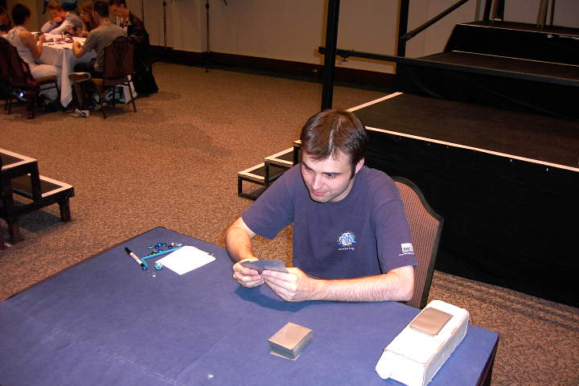
The Magic Invitational in Cape Town this year was my fifth one. That puts me in some poor company - only Mike Long has as many invites. On the upside, however, it does put me in a unique position to compare this year's tournaments to the Invitationals of the past. I'll be sizing things up tourney by tourney, pointing out where this year's event surpassed others, and where it fell short.
Before I really get going, I'd like to thank everyone who once again voted for me this year. I love gaming, and getting flown to another country to play Magic is about the best gaming there is. I hope I'm not disappointing any of you. I do my best to not only do well in tourneys, but also be as entertaining as possible. Keep voting for me, and I'll try and keep doing the same stuff I've been dong for years.

Hong Kong: 1997
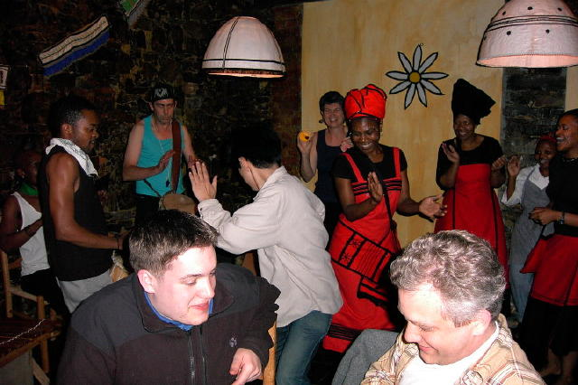
This was clearly a pretty crappy tournament. I was not even invited. I'm not even sure that I'm unhappy about that. A week of hanging out with the likes of Hammer, Mike Loconto and Amiel Feldman doesn't exactly appeal to me. Scott Johns is the only link between Hong Kong and Cape Town, so you'll have to ask him if you want an in-depth comparison. Cape Town definitely wins on the food end. Thursday night, we had a fairly amazing meal of African cuisine that featured a wide array of vegetarian dishes (myself, Dave Price, and Scott Richards are vegetarians, for more info see www.goveg.com) and some serious booty shaking by Tsuyoshi Fujita. I've never seen a gamer move that quickly. I'm told the food was absolutely horrendous in Hong Kong, but the tourney was in a restaurant and you could actually have food delivered straight to your match.

Rio: 1998

Olle and Tommi Hovi became Magic's version of Jay and Silent Bob in Rio, but Olle's solo career really blossomed in Spain.
Rio has something going for it that no other tourney has: rabid crowds of Magic fans. I'm talking about bustling crowds of gamers pushing forward to try and get my autograph. I'm not making this up. The only downside is that they all thought I was John Yoo. They didn't seem to notice that I wasn't short, balding, or Asian. No other Invitational has had nearly that much spectator interest; Malaysia runs a distant second place. Rio also stands out as the only Invitational where there was no tour. Even if there had been a tour in Rio, I doubt it would have compared to the sites we saw in South Africa. I saw cheetahs. I saw penguins. I saw dolphins. I watched seasick gamers vomit again and again (which makes the aforementioned booty shaking by Fujita even more amazing). I saw a drunken Matt Vienneau nearly fall off a boat into an ocean allegedly brimming with sharks. Of all these things, I think I enjoyed the penguins the most. There is something disturbing about looking out over a beach onto a never-ending sea of waddling, screaming penguins. Another interesting factoid: these particular penguins are known as Jackass Penguins. I can only assume that South African naturalists named them this in anticipation of Vienneau's visit.

Barcelona: 1999
What I remember mostly about Barcelona was falling desperately in love with Olle Rade. Olle and Tommi Hovi became Magic's version of Jay and Silent Bob in Rio, but Olle's solo career really blossomed in Spain. Barcelona was really the so-so Invitational: everything was pretty much good but not great. Mike Long won this event, so that pretty much blots out most of the happy memories from this tourney. On the upside, it was David Price's first Invitational. While re-reading Catch-22 recently, I came across a character named Colonel Cargill, who is described as "a self-made man who owed his lack of success to nobody". The same can be said of Dave.

Kuala Lumpur: 2000
This was a great tournament, and not only because I won it. Cool city, nice hotel, early morning basketball, and lots of bowling made this a good time. Winning was the best part, though. I didn't win in Cape Town, as you've probably noticed. I expected good things this year because there was no Solomon Draft, which is an automatic 0-3 for me. Despite having a good Standard deck and an acceptable 5-Color deck, I couldn't put it all together this year. Malaysia also had a really great roster of players who haven't been back to the Invitational: Brian Hacker, Pat Chapin, Dave Humpherys, Dirk Baberowski and Steve OMS are great guys to hang out with for a week. Those guys are a lot more fun that sitting through three hours of "my upkeep and effects I may or may not have with Kamiel Cornelissen."

Sydney: 2000
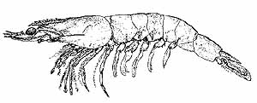
Does South Africa suffer from a lack of prawns?
Holy Ben Seck! I would say that the one thing that prevents Cape Town from having any hope of matching up to Sydney is a lack of Ben Seck, but I'd be lying because Ben Seck was actually there. I can't think of a bad thing to say about Sydney. In fact, if you might just want to read my report from last year. It's much funnier that this one.

Cape Town: 2001
We played some Magic this year. I did okay. If Kai hadn't won, I might have something interesting to say, but instead exactly what you expected to happen happened. I'm just going to skip to the tradition I started last year. I present...

Events That May or May Have Not Happened
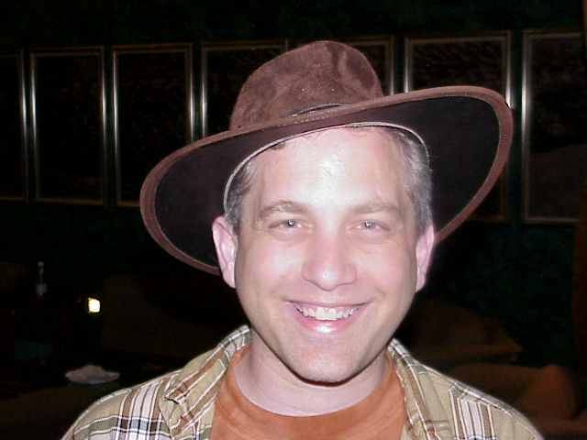
1. Brian Kibler was introduced to an attractive woman, and promptly vomited.
2. Rather than vomit near this woman, he actually vomited onto her.
3. Despite it costing only a small fee, a crew of topless women did not staff our boat tour.
4. The bartenders on the boats were nice to look at, regardless of their tops.
5. Mark Rosewater did not wear this hat:
6. Kamiel stole six hours of my life.
7. I did not see a single prawn all week.
8. The bartender at the casino had trouble making change for $2 USD.
9. Chris Benafel fell asleep while flying above the city in a helicopter.
10. A number of players discovered independently that the hotel's pay-per-view was not properly functioning.
11. Saturday night was a very good time.
12. It didn't get really good until Mikey P showed up.
13. Certain entertainers don't immediately notice that Ben Seck speaks English.
14. Jon Finkel "could not believe he was petting a cheetah"
15. "Seriously" Jon Finkel was petting a cheetah.
16. A number of us were informed that Jon was petting a cheetah.
17. Scott Johns knew a lot about wines.
18. The woman running the wine tasting hated him anyway.
19. Chris Benafel disappeared for quite awhile.
20. His wallet was a bit lighter when he returned.
21. The Invitational ended with someone Tinkering for a Jeweled Bird.
How embarrassing.

